# **Irreversible vs Reversible Reactions**

**Irreversible Reactions**

* An irreversible reaction (also called a unidirectional reaction), is a reaction in which the reactants convert to products, and the products cannotconvert back to the reactants. An example of an irreversible reaction is combustion.

CxHy + O2 → CO2 + H2O ∆H = -ve

* A reaction may be irreversible due to many reasons, the most common being:
  + **separation of products** (e.g. as sold precipitate or a gas form in a solution)
  + **thermodynamics** (reactions with similar activation energy in both directions more likely to be reversible). Therefore, highly exothermic reactions such as burning are unlikely to be reversible.

**Characteristics of irreversible reactions**

* These reactions proceed only in one direction (forward direction),
* These reactions proceed to completion,
* The arrow (→) is placed between reactants and products

**Reversible reactions**

* 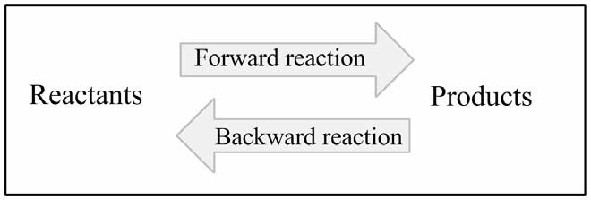A reversible reaction occurs when the backwards reaction (products 🡪 reactants) takes place relatively easily.
* A reversible reaction results in a mixture of reactants and products.
* In a reversible reaction, both the forward and backward reactions are **always** occurring.
* Every reaction can theoretically go in reverse, however reversible reactions are most common when there are low activation energies in both directions and the reactants and products remain as a mixture (don’t separate).
* Double arrows are used to indicate a reversible reaction. An example of a reversible reaction is adding a weak acid to water.

http://www.chemguide.co.uk/physical/acidbaseeqia/ethanoiceqm.gif

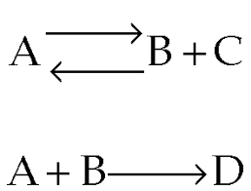

Reversible reaction (double arrows)

Irreversible reaction (single arrow to right)